

**Warrawong High School - Parent Portal**

The Warrawong High School parent portal provides parents with 24/7 access to their child’s data. Parents can log in to access their child's report, attendance information and welfare details as well as updating family contact details.

All student already have access to a Student Portal that is a one-stop shop for everything they need.

Using their current individual login for the school network, students can access their timetable, assessment marks, attendance history and reports from anywhere at any time.

Please log on to the Internet and register for access to our Parent Portal here:

**http://web1.warrawong-h.schools.nsw.edu.au/portal/register**

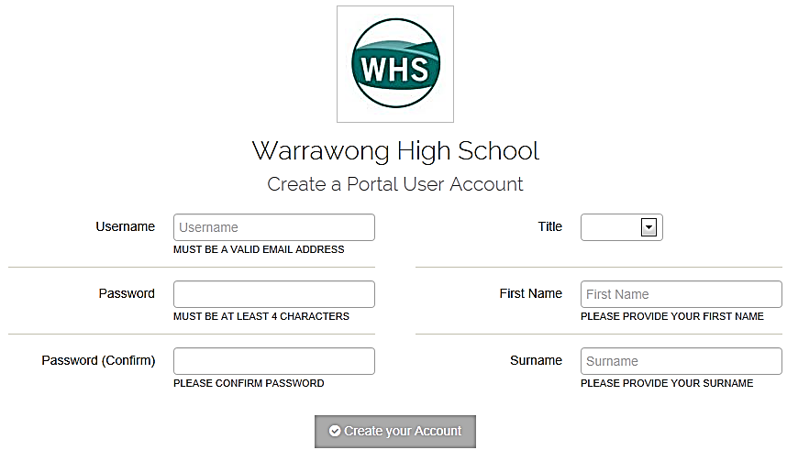

Complete the form with the required information and Create your Account. You must use a valid email address to create your username.

Within a few days you will receive an Email containing your **Access Code** to enter the Portal.

I am confident that you will see the benefits of your registration immediately and be part of our journey in providing this facility to you.

As we progress this initiative, I am confident that the Parent Portal will become more and more significant in your day to day management of your child's enrolment at our school.